## Prompt1: TPW

Promptv1:

Initial structure:

Long Clickable Buttons: ['Back', 'Overview', 'Home']

Clickable Buttons: ['Allow', 'Don’t allow']

Other Buttons: ['10:37', 'Android Setup notification: Finish setting up your sdk_gphone64_x86_64', 'Google Play Protect notification: Google Play Protect is turned on', 'Settings notification: Virtual SD card', 'Wifi signal full.', 'Phone signal full.', 'Battery 100 percent.', 'Allow AnkiDroid to access photos, media, and files on your device?'].

click Allow.

Output structure:

Long Clickable Buttons: ['Navigate up', 'Add', 'Back', 'Overview', 'Home']

Other Buttons: ['10:37', 'Android Setup notification: Finish setting up your sdk_gphone64_x86_64', 'Google Play Protect notification: Google Play Protect is turned on', 'Settings notification: Virtual SD card', 'Wifi signal full.', 'Phone signal full.', 'Battery 100 percent.', 'AnkiDroid', '0 cards due (0 min)', 'Default', '0', '0', '0', 'Studied 0 cards in 0 minutes today'].

click Navigate up.

Output structure:

Long Clickable Buttons: ['Decks', 'Card browser', 'Statistics', 'Back', 'Overview', 'Home']

Clickable Buttons: ['OFF']

Other Buttons: ['10:37', 'Android Setup notification: Finish setting up your sdk_gphone64_x86_64', 'Google Play Protect notification: Google Play Protect is turned on', 'Settings notification: Virtual SD card', 'Wifi signal full.', 'Phone signal full.', 'Battery 100 percent.', 'Night mode', 'Settings', 'Help', 'Send feedback'].

click Settings.

Output structure:

Long Clickable Buttons: ['Back', 'Overview', 'Home', 'Navigate up']

Other Buttons: ['10:38', 'Android Setup notification: Finish setting up your sdk_gphone64_x86_64', 'Google Play Protect notification: Google Play Protect is turned on', 'Settings notification: Virtual SD card', 'Wifi signal full.', 'Phone three bars.', 'Battery 100 percent.', 'Preferences', 'AnkiDroid', 'General settings', 'Reviewing', 'Non-deck-specific reviewer settings', 'Appearance', 'Change themes and default font', 'Gestures', 'Use taps and swipes instead of buttons', 'Advanced', 'Optimization and experimental features'].

click AnkiDroid.

Output structure:

Long Clickable Buttons: ['Back', 'Overview', 'Home', 'Navigate up']

Other Buttons: ['10:38', 'Android Setup notification: Finish setting up your sdk_gphone64_x86_64', 'Google Play Protect notification: Google Play Protect is turned on', 'Settings notification: Virtual SD card', 'Wifi signal full.', 'Phone two bars.', 'Battery 100 percent.', 'AnkiDroid', 'Sync', 'AnkiWeb account', 'Not logged in', 'Fetch media on sync', 'Automatically fetch missing media when syncing', 'Automatic synchronization', 'Sync automatically on app start/exit if the last sync was more than 10 minutes ago.', 'AnkiDroid', 'Deck for new cards', 'Use current deck', 'Language', 'System language', 'Error reporting mode', 'Ask me', 'Notifications', 'Notify when', 'Pending messages available', 'Vibrate', 'Blink light'].

back.

Output structure:

Long Clickable Buttons: ['Back', 'Overview', 'Home', 'Navigate up', 'Synchronization', 'More options', 'Add']

Other Buttons: ['10:38', 'Android Setup notification: Finish setting up your sdk_gphone64_x86_64', 'Google Play Protect notification: Google Play Protect is turned on', 'Settings notification: Virtual SD card', 'Wifi signal full.', 'Phone two bars.', 'Battery 100 percent.', 'AnkiDroid', '0 cards due (0 min)', 'Default', '0', '0', '0', 'Studied 0 cards in 0 minutes today'].

Above is an app flow, containing page text and actions to reach other pages. Ignore battery, time and signal fluctuates in page content and coordinate in actions and do not evaluate them in the following question. Is there any inconsistency, a discrepancy, a logical error, or a bug in the output after the given test sequence? Provide your answer with yes or no, and the reason. The reason should be biref and concise

### Answers:

Yes, there is an inconsistency in the output after the given test sequence. The inconsistency lies in the change from "Clickable Buttons: ['Allow', 'Don’t allow']" to not showing these options again after the initial click on "Allow." This change suggests a progression through the app's permissions flow, but subsequent navigations and actions do not reintroduce or reflect a change that would logically revert or show similar permission requests, indicating a flow that progresses logically without reverting back to initial permission states.

## Prompt2: TPW

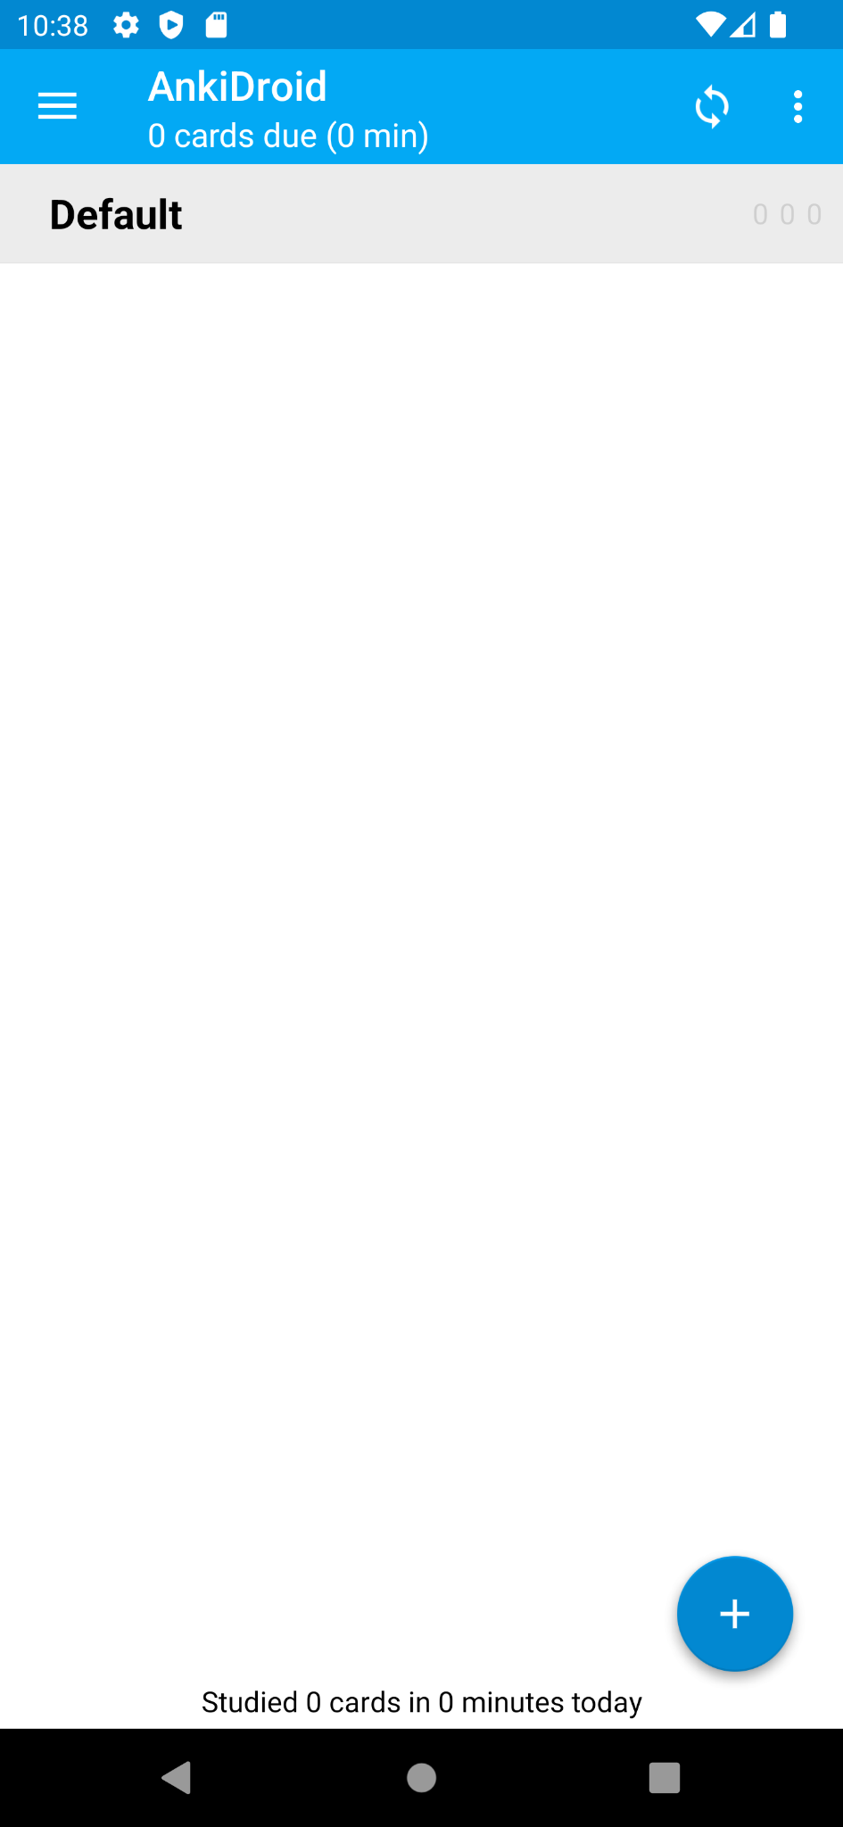

This is the last page screenshot of the above app flow. Do not consider battery, time and signal fluctuates. Is there any inconsistency, a discrepancy, a logical error, or a bug in the output after the given test sequence? Provide your answer with yes or no, and the reason. The reason should be brief and concise.

### Answers:

Yes, there is a discrepancy. The main screen indicates that there are "0 cards due," suggesting no study activity is required at the moment. However, the bottom of the screen states "Studied 0 cards in 0 minutes today," which is inconsistent with the user having completed a test sequence that should have resulted in at least some cards being reviewed. If the test sequence involved studying any cards, the count should reflect the number of cards studied and the time spent, rather than both being zero.

## Prompt3: TPW

Prompt v3:

Action List:

click Allow

click Navigate up

click Settings

click AnkiDroid

back

Final output structure:

Long Clickable Buttons: ['Back', 'Overview', 'Home', 'Navigate up', 'Synchronization', 'More options', 'Add']

Other Buttons: ['10:38', 'Android Setup notification: Finish setting up your sdk_gphone64_x86_64', 'Google Play Protect notification: Google Play Protect is turned on', 'Settings notification: Virtual SD card', 'Wifi signal full.', 'Phone two bars.', 'Battery 100 percent.', 'AnkiDroid', '0 cards due (0 min)', 'Default', '0', '0', '0', 'Studied 0 cards in 0 minutes today']

Above is an app flow, containing the actions from the first page to reach other pages and the last page text. Ignore battery, time and signal fluctuates in page content and coordinate in actions, and do not evaluate them in the following question. Is there any inconsistency, a discrepancy, a logical error, or a bug in the output after the given test sequence? Provide your answer with yes or no, and the reason. The reason should be brief and concise.

### Answers:

Yes, there is a logical inconsistency in the provided test sequence and the final output structure. The test sequence includes the action "click AnkiDroid" which suggests that the AnkiDroid settings or features within the AnkiDroid app would be accessed. However, the final output structure lists "AnkiDroid" under "Other Buttons" without any indication of the actions taken within the AnkiDroid app or changes to the UI that would reflect having clicked on AnkiDroid. This inconsistency suggests a discrepancy in the actions taken versus the final reported state of the UI elements.

## Prompt4:TPW

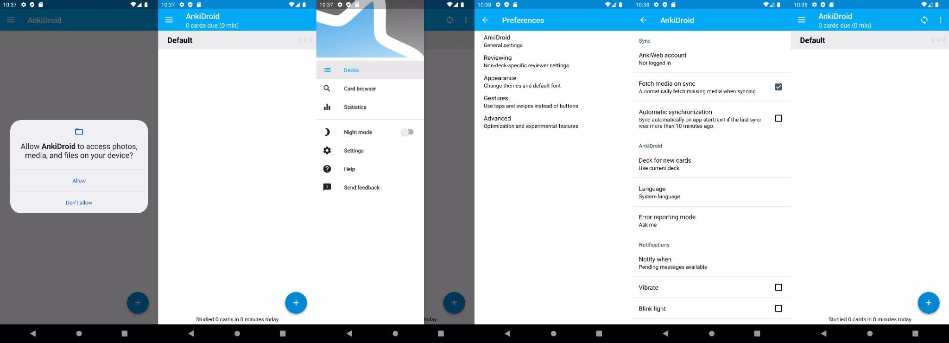

Attached is the screenshot page sequence of an app flow. Ignore battery, time and signal fluctuates in page content and coordinate in actions, and do not evaluate them in the following question. Is there any inconsistency, a discrepancy, a logical error, or a bug in the output after the given test sequence? Provide your answer with yes or no, and the reason. The reason should be brief and concise.

### Answers:

Yes, there is an inconsistency. The first image shows a dialog asking the user to allow AnkiDroid to access photos, media, and files on the device. However, the subsequent images show the app interface as if the user had already proceeded past this dialog, indicating they likely granted permission. If the permission had not been granted, the app should typically not proceed to the main interface shown in the second and third images, as accessing files is usually a fundamental requirement for such an application to function properly.

## Prompt5: TPW

Sequence page structure:

Page content:

Long Clickable Buttons: ['Back', 'Overview', 'Home']

Other Buttons: ['10:37', 'Android Setup notification: Finish setting up your sdk_gphone64_x86_64', 'Google Play Protect notification: Google Play Protect is turned on', 'Settings notification: Virtual SD card', 'Wifi signal full.', 'Phone signal full.', 'Battery 100 percent.', 'Allow AnkiDroid to access photos, media, and files on your device?']

Page content:

Long Clickable Buttons: ['Navigate up', 'Add', 'Back', 'Overview', 'Home']

Other Buttons: ['10:37', 'Android Setup notification: Finish setting up your sdk_gphone64_x86_64', 'Google Play Protect notification: Google Play Protect is turned on', 'Settings notification: Virtual SD card', 'Wifi signal full.', 'Phone signal full.', 'Battery 100 percent.', 'AnkiDroid', '0 cards due (0 min)', 'Default', '0', '0', '0', 'Studied 0 cards in 0 minutes today']

Page content:

Long Clickable Buttons: ['Decks', 'Card browser', 'Statistics', 'Back', 'Overview', 'Home']

Other Buttons: ['10:37', 'Android Setup notification: Finish setting up your sdk_gphone64_x86_64', 'Google Play Protect notification: Google Play Protect is turned on', 'Settings notification: Virtual SD card', 'Wifi signal full.', 'Phone signal full.', 'Battery 100 percent.', 'Night mode', 'Settings', 'Help', 'Send feedback']

Page content:

Long Clickable Buttons: ['Back', 'Overview', 'Home', 'Navigate up']

Other Buttons: ['10:38', 'Android Setup notification: Finish setting up your sdk_gphone64_x86_64', 'Google Play Protect notification: Google Play Protect is turned on', 'Settings notification: Virtual SD card', 'Wifi signal full.', 'Phone three bars.', 'Battery 100 percent.', 'Preferences', 'AnkiDroid', 'General settings', 'Reviewing', 'Non-deck-specific reviewer settings', 'Appearance', 'Change themes and default font', 'Gestures', 'Use taps and swipes instead of buttons', 'Advanced', 'Optimization and experimental features']

Page content:

Long Clickable Buttons: ['Back', 'Overview', 'Home', 'Navigate up']

Other Buttons: ['10:38', 'Android Setup notification: Finish setting up your sdk_gphone64_x86_64', 'Google Play Protect notification: Google Play Protect is turned on', 'Settings notification: Virtual SD card', 'Wifi signal full.', 'Phone two bars.', 'Battery 100 percent.', 'AnkiDroid', 'Sync', 'AnkiWeb account', 'Not logged in', 'Fetch media on sync', 'Automatically fetch missing media when syncing', 'Automatic synchronization', 'Sync automatically on app start/exit if the last sync was more than 10 minutes ago.', 'AnkiDroid', 'Deck for new cards', 'Use current deck', 'Language', 'System language', 'Error reporting mode', 'Ask me', 'Notifications', 'Notify when', 'Pending messages available', 'Vibrate', 'Blink light']

Page content:

Long Clickable Buttons: ['Back', 'Overview', 'Home', 'Navigate up', 'Synchronization', 'More options', 'Add']

Other Buttons: ['10:38', 'Android Setup notification: Finish setting up your sdk_gphone64_x86_64', 'Google Play Protect notification: Google Play Protect is turned on', 'Settings notification: Virtual SD card', 'Wifi signal full.', 'Phone two bars.', 'Battery 100 percent.', 'AnkiDroid', '0 cards due (0 min)', 'Default', '0', '0', '0', 'Studied 0 cards in 0 minutes today']

Above is an app flow, containing the actions from the first page to reach other pages and the last page text. Ignore battery, time and signal fluctuates in page content and coordinate in actions, and do not evaluate them in the following question. Is there any inconsistency, a discrepancy, a logical error, or a bug in the output after the given test sequence? Provide your answer with yes or no, and the reason. The reason should be brief and concise.

### Answers:

Yes, there is an inconsistency regarding the navigation and notification icons that appear across the pages. Despite navigating through different parts of the app, the notifications about "Android Setup," "Google Play Protect," and "Settings" related to the virtual SD card remain constant. This could suggest that the notifications are either persistent in a way that's not typical for changing app contexts or that the sequence incorrectly represents the static state of these notifications across diverse app functionalities.

## Result Analysis

When user clicks ‘back’, it will not return to settings, instead, it return to the main screen. Actually there is no logic errors or UI errors, it is just because this behavior is different from previous versions